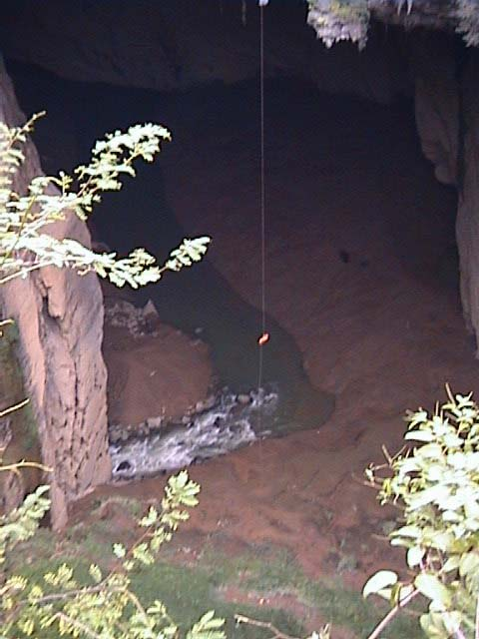

Figure 33: “Guangxi 2000” Caver abseiling 150m entrance pitch, during first descent of Yanliu Dong; on the RHS inside the cave, cavers discovered that a side passage cave had been enlarged by machinery forming an excavated tunnel (Yanliu Suidao), constructed to channel floodwaters to the Xigia hydro power station. (Photograph by Mike Pitt.)

At the base of Yan Liudong (Figure 38), an unexplored upper level phreatic tube passage appears to bypass the turbulent underground river.

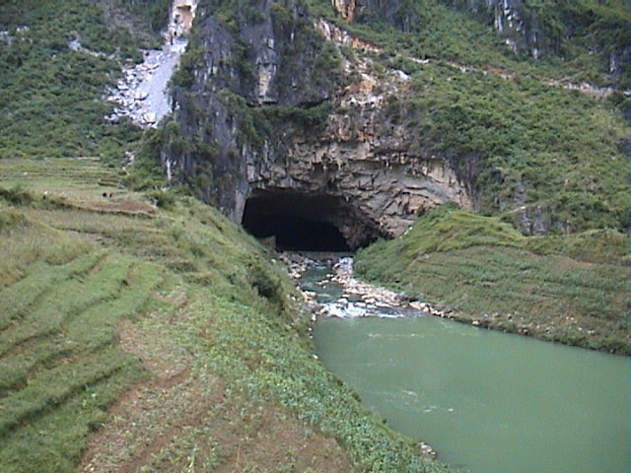

Figure 34: Efflux of Chengbi Hedong, south of Lingyun township (Photogtraph by Mike Pitt)

Chengbi Hedong (= Chengbi River Cave)
Two entrances: sinking stream at altitude of 367m; resurgence at altitude of 363m (Figure 34). Not surveyed, but estimated to be in excess of 700-800m long. Large uropygids (whip scorpions) and crabs found at different locations: on silt banks, dry boulders near the water line and on shingle stone sandy streamside beaches.

(c) Karst Area in Le Ye (Leye) County

Accompanied by an entourage of officials (as happened in the Lingyun area), the Guangxi 2000 expeditioners were the first foreigners (and westerners) to visit this karst district.

Luo Mei Dong (= Sister Mei Cave; a show cave)
Altitude: 970m; total length (of surveyed section) = 456.00m; vertical range = 17.13m. With three entrances, and only partially developed, Luo Mei Dong is an old long established show cave, testified by the well worn entrance steps; its stream only flows in winter months. The present entrance to Luo Mei Dong overlooks the town of Leye, being located above where the main river from Leye township disappears into the hillside. It is virtually horizontal in its entirety and is gated at the far end before it joins the main river; however, a new tourism development is being commenced from this other far end. (Beyond the far end efflux, the stream passes along a short distance of valley floor – effectively a karst window – before disappearing underground again into another section of long and extensive, but unexplored stream passage. A characteristic feature of the already developed show cave part of Luo Mei Dong is the so-called lotus formations: large “mushroom-like” speleothem growths that form islands in the extensive surrounding shallow crystalline floored pools. There are no large chambers, but the cave has two levels, both of which are consistently well decorated. Separate to the show cave, the main river passage seemed feasible, but it was not explored.

Nuping Dong (= Buffalo Cave 1)
Altitude 944m; total plan length = 1234.60m; total vertical extent = 51.75m. One of a series of three relatively close horizontal stream passage caves adjoining streamside pastures - grazed by water buffalos (and geese) – where extensive subterranean passage sections follow the same river course that goes underground, re-emerges and then goes underground again. Very large cave passages with an abundant diversity of cave fauna including lamellibrach mollusc shell banks up to 1km underground and extensive guano mounds with guanophiles and the mucous beaded silken threads of non-glowing keroplatid glow-worms.

Nuping Dong 2 (= Buffalo Cave 2)
Altitude: 940m; total plan length = 241.29m; total vertical length = 17.04m. Only partially explored, this is the downstream extension to Nuping Dong 1.

Fong Yen
Altitude: 1114m; total length of survey = 1120.80m; total vertical range = 407.67m. This is essentially a 400m deep canyon that could be a tributary of a large river system. Access involves descending heavily vegetated slopes and near vertical walls before joining the huge canyon, which is shadowed by jutting roofs of limestone. There was very little water present other than pools, but this is clearly an active system judging by the clean water-washed walls. No obvious camp or safe area found so far, that would provide a refuge in flood conditions. It was explored over a 3-day period, to a point where daylight was lost and we ran out of rope. 500m of rope is required to this point. The way on is open apart from a small pitch, but given the hostile nature of the passage, future exploration will be very committing. There was no evidence of previous exploration. Like many other vertical cave systems it acts as a mammal trap and during a subsequent visit in March 2002, two “feimao” (flying cats) were discovered sheltering in a crevice beside a shingle gravel beach (Figure 39) , 350m down this cave canyon. Subsequently identified from photographs as species of Red-and-White Giant Flying Squirrels (Petauridae: Petaurista alborufus), these two large frightened animals were rescued by cavers who cautiously stuffed them into rope tackle bags and back-packed them to the surface!

Dashiwei Tiankeng
Altitude: 1332m; width = 600m x 425m; total vertical range to cave entrance = 613m. This tiankeng is a spectacular feature, believed to be the 2nd biggest doline (by depth) in the world. Dashiwei Tiankeng was descended over a 3-day period to a large river cave roughly following a route pioneered by an expedition of Chinese Army cavers a few months earlier in July 2000. Access to the tiankeng was gained through Mafeng Dong: a high upper level fossil system which gave access to a traverse ledge permitting a 50m abseil into another fossil cave: Zhong Dong where a bivouac camp was established. A 70m free hang from the bivouac placed expeditioners at the top of a steep scree slope in a primeval forest; it took over an hour to descend this slope to the cave entrance of Dashiwei Tiankeng Dong. (See previous description and Figures 20-24.)

Dashiwei Tiankeng Dong
Altitude: 719m (Figure 24 shows view to entrance, 613m below surface entrance at 1332m); total length of survey = 1189.45m; total vertical depth = 210.21m. Although only partly explored in October 2000, the Dashiwei Tiankeng Dong river passage was followed downstream for 1.1km to a point just beyond its confluence with an equally large river. It was possible to maintain progress out of the water most of the time, but this necessitated many tyrolean river crossing traverses in order to avoid the steep-sided silt banks and the deep and turbulent flowing sections. During the previous partial exploration by “flycat” cavers from the Chinese Army Expedition in July 2000 (when no survey was undertaken), one of the soldiers was swept away (and never seen again) while crossing a turbulent section of this underground river passage. The only known possible resurgence is believed to 30km away at Beilong.
Xiongjia Dong East (= East Cave)
Altitude not recorded; total length of survey shots = 1773.10m; total vertical range = 94.31m. A large fossil cave with considerable formations and large internal volume. Takes the same line as West Cave, separated by a doline. There was evidence of previous exploration by local people. Considered to have potential as a show cave, although is presently inaccessible.

Xiongjia Dong West (= West Cave)
Altitude: 1299m; total length of survey = 1358.70m; vertical range = 158.27m. Similar description to Xiongjia Dong East cave with potential for development as a show cave.

A number of the caves visited in both the Lingyun and Leye areas showed evidence of previous use, including mining of nitrate from old consolidated guano deposits. The ingenuity used to gain access to some sites was quite amazing including the use of bamboo poles and ladders to reach deep cave sites such as Zhong Dong down the inside of the Dashiwei Tiankeng. There was also evidence of the elaborate “manufacture” of sliced lengths of halved bamboo stalks, gouged out and used as water channelling conduits.

Historical use of caves in China and their exploration

Living in carbonate rock areas for several thousand years, the Chinese have been utilising karst resources since before the time of Christ. Around 214 BC, during the Qin Dynasty, the 30metre long Ling Canal was dug in the Hsinan area of the Guilin region in Kwangsi (Guangxi) province, as part of a water conservancy project and around 200 AD during the Eastern Han Dynasty, there is a record of people in Shansi (Shanxi) province using spring water to irrigate farmland (CAGS, 1976). Although most karst areas have been utilised for hundreds of years for agricultural purposes, there is scattered evidence of other cultural use including the presence of pavilions or pagodas on the pointed tops of karst pinnacles or cone karst peaks. Caves in China have also been used as ceremonial and habitation sites from times before the birth of Christ and many caves are still used today for similar purposes including burial site tombs or graves, Buddhist worshipping temples, ritual sites (with incense burning) and sometimes as shelter sites for hermits or shamans. Many caves are adorned with calligraphy (see Figure 35), where poets have written verse, some of which have been over-written by political propaganda. Some regularly frequented caves near villages have ornate statues or figurines in their entrances, plus decorative or carved stonework including bridges and excavated entrance stairs. In more remote areas, there are cave entrances with the remains of raised bedding structures behind fortress-like rock walls, where local villagers or farming families probably lived, protected from marauding predators or hiding from their enemies in the time of feuding warlords.

Documentation of caves in China dates back to relatively ancient times. In northern China, caves and cave hydrology were described in “The Mountain Scriptures” – a book written over 2200 years ago (Waltham, 1986). Around 900 years ago, (Northern Sung Dynasty), Shen Ko discussed the origin of stalactites in a book titled: Study Notes of Dreaming Stream Garden (CAGS, 1976). In 1541, a cave in eastern Yunnan was described as the site containing a blind cavefish (Chen, et. al., 2002). In southern China, Xu Xiake (1587-1641) is revered as the “father” of cave and karst studies. Described as “an outstanding geographer” and self-taught observer from the Ming Dynasty (Ru Jinwen, et. al., 1991), he journeyed to remote parts of south-eastern, southern and southwest China, recording aspects of natural science including the first systematic description of karst in China. In a four year period (1636-1640), he devoted himself totally to karst studies, reporting 357 caves (visiting 306 of them) recording entrances, cave structure and dimensions as well as straw stalactites, helictites, shields and cave pearls (Ru Jinwen, et. al., 1991). Xu Xiake’s notes also record cave animals including bats, snakes and insects (Clarke & Latella, 2001). Collated posthumously his journals were published in 16 volumes as Hsu Hsia-ko’s Travels (CAGS, 1976), or “Xu Xiake’s Travels” (Ru Jinwen, et. al., 1991). His statue stands outside the IKG in Guilin (Figure 3).

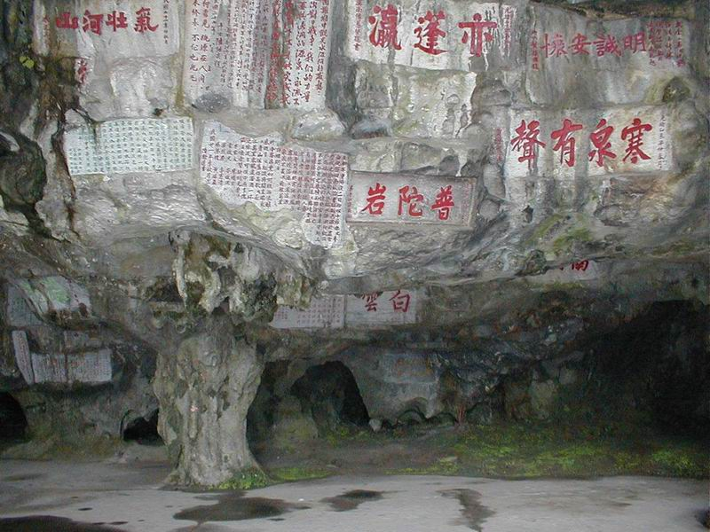

Figure 35: Calligraphy on walls of frequently visited cave site: Shuiyuandong, near township of Lingyun, NW Guangxi Province.

Getting into China on a caving expedition

Although a few tour groups seem to be able to get off the beaten track in China, they are generally confined to the constraints or outskirts of major cities and westernised tourist spots – including show caves. (In China, there are around 270 show caves and many of these are now geared to catering for foreigners including westerners.) In order to access wild caves in the more remote parts of China, you would normally need to have some sort of permission or “letter of invitation” along with an appropriate passport visa. This can be achieved by joining an organised group or expedition that comes to the country by “invitation” from a Chinese based institution that usually desires to enter into some “co-operative” research agreement, forming a working arrangement with the visiting group. In exchange for a pre-determined fee - usually set as a daily rate in US dollars (e.g., $40US per day) - the sponsoring institution assists your visit to China by arranging logistical support, including networking with local municipal, provincial or government officials and the necessary infrastructure of transport, accommodation, facilities and interpreters in order to access or live in remote locations. (Incidentally, the Chinese are very keen to obtain foreign currency, especially US dollars.)

Although it is possible to access remote parts of China with just a tourist visa, if you know what you’re doing (and don’t mind standing in long queues at railway station, bus depot or river ferry ticket counters), or if you are happy to pay for a tour guide that can take you to remote areas. (If you do engage an English speaking tour guide, you have to pay for their travelling and accommodation expenses as well as your own costs.) However, if you want to spend an extended time in remote parts of China, you normally need to have an endorsement on your Visa that states you are there on business. After initially submitting all your personal details to the relevant institution that is sponsoring you (e.g., a University or scientific research centre), they forward your details to a provincial government or central (Beijing) government body: usually the Chinese Ministry of Land and Resources, who then issue the formal Letter of Invitation that you need when applying for your Visa. If you are part of an expedition, the “invitation letter” that you receive may in fact be a group letter with a list of the names, ages, addresses and passport details for all participating expeditioners. After receiving your letter of invitation, you forward this along with your completed China Visa application (obtained from a travel agent) - to say, the Chinese Embassy in Canberra - being sure to record the exact number of days of stay in China and the required length of visa: 30, 60 or 90days. So for example, a 38day expedition would mean applying for a 60day visa. If you need to extend your Visa, again it can be done quite easily if you are “in the know”, but this might entail a trip down to Hong Kong. Otherwise, you need to obtain another letter of invitation that has to be enclosed with your Visa extension application.

Apart from having your visa marked with a “business” category which enables you to pass through the various road tolls or county and provincial border visa checks and stay at hotels in remote areas, another reason for your accompaning “letter of invitation” is that it ensures that as a “foreigner” you have a support network or infrastructure to assist in provedoring for expedition needs, plus transport, accommodation and interpreters. It is especially important to have the required “permissions” from various local government, provincial or central government level officials in China in order to access remote areas away from major urban centres. The logistical support may include the representatives of any local or regional tourism authority, and certainly would include the local municipality or County police force and transport authorities (for bus transport etc.), plus a range of other Chinese officials representing villages and/ or Minority groups, the local municipality or nearest town, the County town and/ or nearest cities, neighbouring Counties and various Provincial-based and occasionally national (central) government officialdom. The host body – or individuals of “esteem” within these host bodies - who arrange your invitation, organise this support network along with assistance from any endorsement of the local or central government body that provided your letter of invitation sent to your embassy with the visa application.

Getting invitations from institutions and accommodation

Some of the hosting or sponsoring institutions that have provided invitations to foreigners as individual speleo specialists and/ or cavers in an expedition include:
- The Institute of Karst Geology (IKG), especially the Karst Dynamics Laboratory (KDL) of Guilin in Guangxi Province - more commonly known as the “Karst Institute of Guilin” - (a section of the Guangxi Normal University in Guilin);
- Guilin College of Geology in Guangxi Province;
- Biological, geological or geographical sections of the Guizhou Normal University based in Guiyang (capital of Guizhou Province), e.g., the Dept. of Biological Sciences and its sub-section: “Center for Animal Studies of Karst Caves”;
- Guizhou Institute of Technology in Guiyang (Guizhou Province);
- South China Normal University based in Guangzhou (formerly known as Canton) in Guangdong Province;
- University of Chengdu (College of Geology) in Sichuan Province;
- Chengdu Institute of Technology (in Sichuan Province);
- The Beijing based central office body of the Chinese Academy of Sciences (CAS) – (known in China as Academia Sinica) - including the various subsidiary or component bodies such as the CAS Institute of Geology, Institute of Geography and Institute of Zoology;
- Regionally based or provincial centres of CAS such as the Guizhou Academy of Sciences or subsidiary sections such as the Kunming Institute of Geography or Kunming Institute of Zoology (in Yunnan Province).

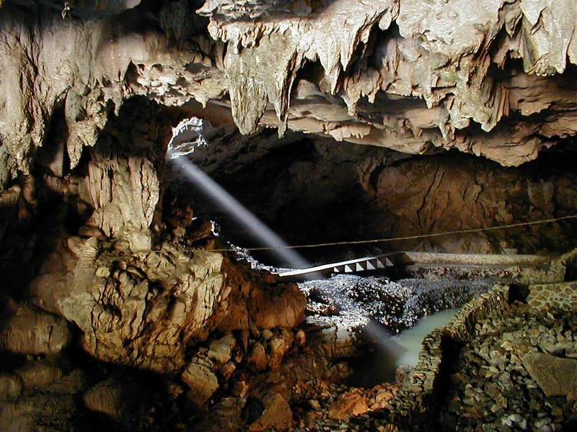

Figure 36: Ray of sunlight pierces roof opening into Shuiyuandong near Lingyun.

Although you may occasionally be very fortunate to be offered accommodation with one of your hosting institution staff members, this is rare, because the Chinese are often very modest about showing their homes to westerners and/ or because they often live in relatively deprived circumstances with no spare rooms for guests. Many of the institutions that organise invitations for expeditioners have accommodation wings and sometimes on-campus hotel style establishments. Such places have rooms of varying standards, designed to house students, visiting academics or foreign guests. You can usually ascertain your guest level status, depending on various factor levels of comfort on a sliding scale between the extremes of very good and not so good:
- the cost of your accommodation - if any – and whether you are charged expensive rates in US dollars or cheaper rates in Chinese RMB (or Yuan);
- whether you are in a single room, perhaps with TV, air conditioning or ceiling mounted fan, or in a share room with very few facilities and a varying number of beds (sometimes with mosquito netting provided);
- the type of bedding provided and whether your bed has regular mattress or is simply sheets of corrugated cardboard over a flat (or slat) wooden base;
- the type of toilet: a normal western style toilet with lift up lid and seat flap; a low seating squat type toilet bowl; or a “floor squat” over hole in the floor;
- the type of ablutions: a regular shower with taps and normal sprinkling shower rose head with hot water any time of day or just a lever operation for water that issues from an over-head mounted pipe outlet (with hot water only available when the wood or coal-fired kitchen stoves are operating during late afternoon/ early evening hotel meal preparation times);
- washing facilities: hand-basin with taps giving running water and a draining sink via pipe outlet or simply draining into a bucket, or just a bucket filled from shower outlet. In the latter case, the bucket is used as a hand-basin for washing clothes, as well as washing your face and hands, brushing teeth or flushing your squat hole “doings”.

Like many of the hotels in China, these various institutions offer at least two if not three different classes of accommodation. Despite the fact that some expeditioners may be visiting scientists with specialised speleological equipment and computers etc., as expedition members they usually find themselves being housed in the lower class standard working men’s’ quarters. (The obvious class distinction in China can be quite an “eye opener”. The differing accommodation standards at some hotels in China is further evidenced by the varying standards of hotel eating rooms or banquet settings.)

Recent history of cave exploration in China and some reasons for being there

Britain was one of the first “foreign” countries to become involved with Chinese authorities in co-operative karst research and exploration of caves in China, closely followed within a year or two by expeditions from France, New Zealand, Slovakia, Japan and USA. The first expeditions to China by the separate British and New Zealand teams were planned well in advance. In 1982, Andy Eavis and Tony Waltham undertook a tourist trip to Guilin, which effectively became a reconnaissance trip to look at the karst exploration potential in Guangxi Province of SW China. In the following year, some active discussions were commenced between Prof. Yuan Daoxian (from the Institute of Karst Geology in Guilin) and Dr. Marjorie Sweeting (from Oxford University in England). In that same year (1983), Dr. Paul Williams (from the University of Auckland in New Zealand) spent some time in Guiyang (capital of Guizhou) with members of the Geography Department of Guizhou Normal University and began sowing the “seeds of co-operation” between China and New Zealand for future karst research and cave exploration projects (Crossley, Emberson & Yang, 1988). In 1984, Tony Waltham made another visit to China, meeting Song Linhua and inspecting karst areas near Guilin during the course of an overland journey from Hong Kong to England. In that same year, Prof. Yuan Daoxian from the KDL in Guilin subsequently travelled to England to meet British cavers and have discussions with Andy Eavis, inviting him to lead a team of cavers to Guilin the following year in 1985. In that same year (1985), the provincial government of Guizhou and the New Zealand government signed formal agreements to promote scientific and technical co-operation with a particular Clause related to karst research. Following an exchange of letters between Professors Yang Mingde from Guizhou and Paul Williams in 1986, support was given for their joint speleological expedition commencing in 1987.

The first Anglo-Chinese project commenced in 1985 when Andy Eavis and Tony Waltham (Deputy Leader) led “China Caves ‘85”: a British team of ten cavers exploring tower karst and caves near Guilin in Guangxi Province and a Chinese team (supported by the Guizhou Normal University in Guiyang) exploring plateau karst in Guizhou Province. Subsequently known as the “China Caves Project” (CCP), there have been an on-going series of Anglo-Chinese expeditions to caves in southern China ssponsored by the BCRA and Ghar Parau Foundation; most of these expeditions have been led by Andy Eavis. A number of these CCP expeditions in south China have been solely supported by the Karst Dynamics Laboratory (KDL) section of the IKG in Guilin (part of Guangxi Normal University), who are actively engaged in a range of pure and applied karst science studies related to the harnessing of underground waters as well as other environmental concerns. Through the Institute of Karst Geology, the KDL provides “Letters of Invitation” and logistical support to expeditioners.

The more recent expeditions to China have also indirectly fallen under the auspices of a series of UNESCO sponsored five-year plans incorporating karst research in China. A number of Chinese bodies have assisted in the management of these five year plans, including sections of the Chinese Academy of Sciences and several universities: notably the Guizhou Normal University in Guiyang and the Guangxi Normal University in Guilin (particularly the IKG). Cave biology is itself one of the major objectives of the current UNESCO/ IUGS IGCP sponsored 5-year "IGCP-448" project titled: "World correlation on karst geology and its relevant ecosystem (2000-2004)” which focuses on the ecological problems of karst". During the recent expedition, my role involved a study of cave ecosystems and species; this was believed to be one of first known intensive studies of cavernicoles in cave ecosytems of SW China: with a systematic collection or recording of all aquatic and terrestrial species in caves.

As mentioned above, the motivations behind this interest in having “foreigners” assist in exploration of karst areas of southern China, stems from a scientific and economic interest, principally related to hydrology and civil engineering projects (Waltham, 1986) but latterly from increasing demands for more show caves and/ or development of karst tourism projects. This is exemplified by the development of Crown Cave as a show cave; situated beside the Li Jiang (Li River) south of Guilin, it was initially explored and surveyed as the Guan Yan Dong system by the first British team in 1985. The exploration of caves in China has followed the general principle that cavers are fundamental for land managers to foster an understanding and knowledge of the karst and its potential for development. In addition to the British teams, there have been expeditions from France and Italy and several other countries, but none from Australia. There have also been teams of cave biologists studying specific animal groups.

A synopsis of the known caving expeditions to China from foreign countries

Interestingly, although there have been no Australian-based expeditions to China, some Australian caving clubs have visited certain karst areas, e.g., the Victorian Speleological Association visit to caves in the Guilin area of Guangxi Province in 1988. Although possibly not complete, the following list of cave expeditions to China (till date of our expedition in October 2000) is believed to be the first published chronology listing all the known caving expeditions to China from foreign countries. The list has been compiled from a number or sources including the publications of cave exploration reports, the taxonomic descriptions of new species and the annotated bibliographies of annual speleo publications. Some details have also been augmented from the database of Chinese expeditions maintained by a French caver (Jean-Pierre Barbary), who has been to China about a dozen times.

The listings are given in two parts: firstly a record of the known expeditions from the UK, then secondly a list of the expeditions emanating from other countries. Although most of the UK expeditions are in fact composed of cavers from English (or British) clubs, the expeditioners have included cavers from Ireland, Scotland and Wales and sometimes other non-British countries. Most of the UK expeditions have been “China Caves Project (CCP)” trips led by Andy Eavis, but there have been several other English expedition teams in China. Similarly there have been numerous speleo expeditions to China from France and Italy, where expedition teams have been organised from different regions of both countries. For example, the French expeditions have included two groups: firstly the “Franco-Chinoise” expedition members of the Paris-based French Federation of Speleology, and secondly members of the regionally based Adventures Karstiques Lointaines (AKL) group. The nine Italian expeditions have comprised five teams from the Museum of Natural History in Verona (northern Italy) and four teams from a speleological group in southern Italy. The few known Chinese caving expeditions are not included; in most instances, the expeditions originating in China have been co-operative projects running in conjunction with foreign investigations. However, in recent years there have been a few Chinese expeditions to caves from non-academic institutions e.g., the Chinese Army and their team of “Flycats”: a group of adventure caving explorers who risk life and limb in the deep and vertically challenging tiankengs (massive cliff-sided collapse features in cone karst) or in the long often flooded or fast-flowing river stream caves of NW Guangxi Province. The following list records the year date, expedition group and the Province/s visited (with the respective County areas or regions in brackets).

(a) A summarised chronology of the UK-based caving expeditions to China (till 2000):
- 1985: “China Caves ‘85” expedition to eastern Guangxi Province (Guilin, Yangshuo, & Nanxu counties) and western Guizhou Province (Anshun & Shuicheng counties) – led by Andy Eavis and Tony Waltham.
- 1986: CCP Reconnaissance to Du’An County in Guangxi Province – led by Andy Eavis.
- 1987-1988: CCP expeditions to Guangxi Province (Du’An, Mashan and Bama counties) in December 1987 and January 1988 – led by Tim Fogg (with Andy Eavis as Project Leader).
- 1987-1988: CCP expeditions to Guizhou Province (Fala region of Shuicheng County) in October-Nov. 1987 & January 1988 – led by Dick Willis (with Andy Eavis as Project Leader).
- 1988: CCP Reconnaissance in Provinces of Guangxi (Mashan & Long An counties) and SW & southern Hunan (Jin Yi Shan & Chenzhou counties).
- 1988: China ’88 Tien Shan Expedition Reconnaissance to Xinjiang Province (north of Tibet) in NW China – British caving team led by Jim Birchall.
- 1988: Mendips-based expedition to An-Long (in Guizhou) – led by Bruce Dunton (?).
- 1989: “Guizhou ‘89” expedition to An-Long in Guizhou Province – led by Bruce Dunton.
- 1989: CCP “Three Counties Expedition” to Guangxi Province (Bama, Feng Shan & Donglan Counties) – led by Dave Gill.
- 1989: CCP expedition to Sichuan Province (?).
- 1991: CCP Expedition to Yunnan (Mengzi County) – led by Andy Eavis.
- 1992: CCP Expedition to Sichuan Province (Xingwen County) and Tibetan Plateau – led by Andy Eavis.
- 1994: CCP Expedition to Yangtze Gorges and Xin Long in Sichuan Province - led by Richard Bartrop;
- 1995: CCP Reconnaissance to Yangtze Gorges;
- 1996: Major “Yangtze Gorges” expeditions to Jiang Kou and Xin Long areas in Sichuan – led by Andy Eavis (Project Leader) and Brian Judd.
- 1997: Major “China Connection” expedition to Yangtze Gorges – led by Andy Eavis.
- 1998 and 1999: China Connection Expedition: led by Andy Eavis.
- 2000: The “Guangxi 2000” Yorkshire Ramblers Club & Wolverhampton Caving Club expedition to NW Guangxi Province (Lingyun and Leye Counties) – led by Ged Campion.

(b) A summarised chronology of expeditions by other foreign countries (till 2000):
- 1958-1959: Hungarian expedition (led by Balazs) to Yunnan, Guangxi and Guizhou (with the biological studies by Loksa and discovery of the first cave-adapted millipedes in China).
- 1977: Slovenian expedition to southern China (and biological studies by Sket).
- 1980: Japanese expedition (2nd Friendship group for China karst-speleological survey group) to Guangxi (Wuming County) and Yunnan (Lunan County).
- 1985: Reconnaissance by New Zealand team to Guizhou and Guangxi in January 1985.
- 1985: Reconnaissance by French team to Guizhou, Yunnan and Guangdong.
- 1986: 1st “Franco-Chinoise” (French-Chinese) expedition to caves of various counties in central and southern Guizhou Province: Zhijin (central north), Anshun (central west), Ziyun (southern) and Luodian County (far south) – led by Jean-Pierre Barbary.
- 1987: China-New Zealand Exchange expedition to eastern Guizhou (Hezhang, Bijie, Nayong, Dafang, Qianxi and Zhijin counties) in September and NE Guangxi (Guilin region) in October 1987 – nine member team, led by Prof. Paul Williams.
- 1988: 1st (American) Cave Research Foundation (CRF) expedition (with cavers from South China Normal University in Guangzhou) to Guangdong, Hunan and Guangxi provinces – possibly led by Ian Baren (?) and/ or Rondal Bridgemon (?).
- 1988: International (“iedpcr”) expedition to Guizhou Province (Zhijin, Anshun, Xingyi and An Long Counties).
- 1988: Belgo-Chinoise (Belgian-Chinese) expedition to western Hubei Province (Lichuan and Wufeng counties) and Hunan (Sangzhi County) with Kunming Institute of Geology from Chinese Academy of Sciences.
-1988: 1st Sino-Japanese expedition (Fenglin Cave Project of Japan) to Guizhou (Suiyang County).
- 1988-1989: Croatian (Yugoslav) “KINA 1988” expedition to southern Guangxi Province (150km south of Guilin) - lead by Tonaei Radja (?) and/ or Robert Erhardt (?).
- 1989: Gebihe Expedition: 2nd “Franco-Chinoise” (French-Chinese) expedition to Gebong and other caves in Ziyun County of southern Guizhou (and in the counties of Zhijin & Pingtang), plus other regions in Hubei Province (counties of Wufeng, Hefeng, Lichuan & Yichang) and Sichuan Province (Wuxi County) – led by Jean-Pierre Barbary.
- 1989: “Yunnan ‘89” - 1st Sino-Bulgare (Bulgarian-Chinese) expedition to Yunnan (Mengzi, Mile and Jianshui Counties) – possibly led by Trifon Daaliev (?).
- 1990: 2nd Sino-Bulgare (Bulgarian-Chinese) expedition to Yunnan – led by Alexey Jalov (?)
- 1990-1991: Belgian reconnaissance expedition to Eastern Yunnan Province (Xuanwei, Qujing, Xundian and Luxi counties) in December 1990/ January 1991.
- 1991: “Cina ‘91” - 1st Italian expedition to southern China to Yunnan (Puding), Guizhou (Anshun) and Guangxi (Gongcheng).
- 1991: “Guizhou China ‘91” - 2nd Sino-Japanese expedition (1988-1991 Fenglin Cave Project of Japan) to Guizhou (Zhijin and Longli counties).
- 1991: Belgian cavers subsequent expedition to Eastern Yunnan (Mile, Xuanwei, Xundian and Yiliang districts) in March-April 1991.
- 1991: Swiss expedition to Yunnan (Jianshui County)
- 1991-1992: 2nd American (CRF) expedition to southern China (Zhijin County in Guizhou) with speleologists and academics from Guizhou Normal University – led Ian Baren (?) and/ or Rondal Bridgemon (?).
- 1992: Donghe Expedition: 3rd “Franco-Chinoise” (French-Chinese) expedition to caves in karst areas of central China: Hubei and Hunan provinces – led by Jean-Pierre Barbary.
- 1992: Italian expedition to Guangxi Province (Gongcheng County)
- 1992: Adventures Karstiques Lointaines (AKL) Number 1 (French) expedition to caves in Guangxi, Sichuan, Chongqing, Wuhan and Hubei – led by Patrick Schalk.
- 1993: French “Xiangxi ‘93” expedition to Hunan Province (Longshan County).
- 1993: CRF expedition (no further details known).
- 1993: Italian “Sichuan ‘93” expedition to Sichuan (Huaying County).
- 1994: Italian expedition to Guangxi (Gongcheng) and Guizhou (Shuicheng).
- 1995: “Xiangxi’95” French expedition to Hunan (Longshan County).
- 1995: AKL Number 2 (French expedition) to caves at Xin Long in eastern Sichuan (Fengjie County) and in Chongqing, supported by Chengdu University – led by Patrick Schalk.
- 1995: “Huanghou95” Slovenian expedition to Guizhou Province (Libo County and Dushan).
- 1996: Slovakian expedition to Tian Shan mountain karst in Xinjiang-Uygur Province/s (north of Tibet)
- 1996: Slovenian expedition to Guizhou (Shuicheng) and Yunnan (Liuzhi).
- 1997: “Yungui ‘97” French expedition to Guizhou (Shuicheng & Pan Xian) and Yunnan (Liuzhi).
- 1997: “Hunan ‘97” French expedition to Hunan (Longshan County).
- 1997: “Shuidong ‘97” French expedition to Liaoning Province (Benxi Cave, Benxi County).
- 1997: “Shilin ‘97” Spanish expedition to Guizhou (Panxian) and Yunnan (Liuzhi, Lunan & Luoping).
- 1997: Sino-Japanese (RUES) expedition with 10 Japanese cavers from Ritsumeikan University Exploration Society and Regional Karst Geology section along with 4 Chinese cavers from the Institute of Karst Geology explored Renhuai in northern Guizhou in February-March 1997.
- 1997: AKL Number 3 (French expedition) to caves in Sichuan and Chongqing (Fengjie, Wushan, Wuxi and Xin Long areas), supported by Chengdu Institute of Technology – led by Patrick Schalk.
- 1997: “Guizhou ‘97” Italian expedition to Guizhou (Xingyi).
- 1997: “China Caves ‘97” Italian expedition to Guizhou (Ziyun County).
- 1997-1998: Slovakian expedition to eastern Yunnan Province (Zhongdian, Wenshan & Guangnan) - led by Peter Holubek.
- 1998: “Yungui ‘98” French expedition to Yunnan and Guizhou (Liuzhi, Xiuwen, Xiefeng & Lijiang).
- 1998: 3rd CRF “China Caves ‘98” expedition to Guizhou (Dafang) – led by Ian Baren.
- 1999: “Lijiang’99” French expedition to Yunnan (Lijiang area).
- 1999: AKL Number 4 (French expedition) to Sichuan, Yunnan and Hubei (Fengjie, Wuxi and Zhenxiong) during August 1999 – led by Patrick Schalk.
- 1999: Sino-Japanese (RUES) expedition to Guangxi Province.
- 2000: “Hunan 2000” French-Belgian expedition to Hunan (Longshan County) and Hubei.
- 2000: “Panxian 2000” French expedition to Guizhou (Panxian County).
- 2000: Italian expedition to Guizhou (Qianxi County).

In the last 1-2 years, there have been a number of additional sporadic, but roughly consecutive expeditions led by members of the Hong Meigui (Red Rose) Caving Club (HMG). One of the mainstays of HMG is Erin Lynch, an American caver from California; she has maintained a caving base in China for almost 18months.

Some exploration results: the ten deepest and ten longest caves in China

The collation of records pertaining to the longest and deepest caves in China is constantly in a state of flux because of the ever increasing number of exploratory speleo expeditions in China. The new discoveries made with subsequent expeditions (some of which are not immediately recorded), results in changing statistics. Most of these records are sourced from the Hong Meigui (HMG) Caving Club’s internet site titled “Deep and Long Caves in China” (http://www.survex.com/~hmg/deepandlong.htm), checked for accuracy on 09/12/2002. Further detail has been kindly provided by Ms. Erin Lynch (the HMG website compiler), who is currently co-ordinating and organising expeditions in several parts of southern China.
(a) Ten deepest caves in China (December 2002):
- Xiao Zhai Tiankeng near Xin Long township in Fengjie County, Chongqing Province (east of Sichuan) has a depth of 964metres. However, the first 600 vertical metres (involving descent down the cliff-sided walls of a tiankeng) is exposed to daylight, so strictly speaking, may not satisfy the definitions of an (underground) cave.
- Qikeng Dong near town of Tianxing in Wulong County, Chongqing Province. Exploration came to a halt in October 2002, when the cave sumped at 920m depth.
- Dongba, also near Tianxing (in Wulong County, Chongqing) presently 656metres in depth (October-November 2002) and may connect with Qikeng Dong to provide a lower entrance to bypass the sump and increase the depth of the linked cave system.
- Zhai Dong near Yanziping, Hefeng County, Hubei Province – 552metres.
- Wujia Dong in Suicheng County, Guizhou Province - 436metres.
- Gebihe (Amont) near Gebong township, Ziyun County, Guizhou Province – 418metres.
- Da Dong also near Tianxing in Wulong County, Chongqing Province – 413metres.
- Fong Yen in Leye County, NW Guangxi Province – 408metres.
- Dongxi Tiankeng in Wufeng County, Hubei Province – 382metres.
- Baidong near Leye County town, Leye County, Guangxi Province – 368metres.
(b) Ten longest caves in China (December 2002):
- Tenglong Dong in Lichuan County in Hubei Province – 33,522 metres (33.552km).
- Bashui Dong in Jiangkou County, Guizhou Province – 22450 metres (22.450km).
- Chu Yan (Xiniu) Dong near Doshan township, An Long County, Guizhou Province – 17,600 metres (17.6km).
- Duobing Dong in Xiuwen/ and Xifeng counties, Guizhou Province – 17,210 metres (17.21km).
- Feihu Dong in Longshan County, Hunan Province – 17,000 metres (17km).
- Dadong in Wufeng County, Hubei Province – 10,392 metres (10.932km).
- San Wang Dong near Houping, in Wulong County, Chongqing – 10,099 metres (10.099km).
- Dacao Tiankeng in Leye County, Guangxi Province – 9,461 metres (9.461km).
- Mawang in Bama County, Guangxi Province – 9,368 metres (9.368km).
- Zhucaojing Dong in Xingwen County, Sichuan Province – 8,800 metres (8.8km).
Development of caving and caving groups in China

It is estimated that there at any one time, there are around 200 cavers in China, mostly students at tertiary institutions, so caving is a short term pursuit during their few years of study. This number also includes the more professional specialist speleologists such as hydrologists and the few cave biologists who rarely enter vertical cave systems. Although there is no organised or co-ordinated national speleological body in China with a database of recorded caves, there are caves in virtually every province and many more “waiting” to be discovered and explored. The first known caving body formed in China began in February 1984 with the founding of the Speleological Commission of Guizhou Geographical Society. Prof. Yang Mingde was elected as its first Director with Paul Williams (from New Zealand) being invited to be one the speleological commission’s scientific advisers (Worthy, 1994). The second known body of Chinese cavers to be established was formed in 1987 at the South China University at Guangzhou (formerly Canton) in Guangdong (Bridgemon & Lindsley, 1991).

Just an aside about the Chinese language. Like English, the same word in Chinese can have several meanings and in some cases up to ten meanings depending on how the word is sounded! An obvious example is the word “Dong” that we know of as “cave”, The word “Dong” also means “east” as in the aforementioned province name “Guangdong”; and “xi” means west as in “Guangxi”.

There are also cavers at the Institute of Karst Geology in Guilin, some of whom have recently been trained in SRT skills by Erin Lynch and other members of the Hong Meigui Caving Club. It is unknown where the “Flycats” in the Chinese Army (in Leye county) of NW Guangxi province received their training. There are a number of other smaller caving groups that include members with limited SRT training skills including cavers under the guidance of film director Chen Lixin at Guangxi University in Nanning. Similarly, some cavers at various institutes of Chinese Academy of sciences (CAS) have SRT skills, including Liu Hong and Zhang Fan at the Kunming Institute of Geography who have learnt their skill by meeting cavers internationally and studying Al Warild’s book of vertical caving techniques.

Liu Hong and Zhang Fan from the Kunming Institute of Geography (KIG) have a keen interest to form a national body in China, possibly modelled along the lines of the Australian Speleological Federation (ASF). In an effort to further this process, I travelled to Kunming earlier this year (2002) in order to have some preliminary discussions with both Liu and Zhang and a few other Chinese speleologists. (Herein I will relate another interesting experience which could probably only happen in China! I had been given a card with the name and address of Zhang Fan (my primary contact in Kunming) , who is the Director of the Nature Branch in the KIG. Although Zhang’s name and address was clearly and correctly inscribed with Chinese characters, a taxi driver took me from the Kunming railway station to the Kunming Institute of Geometry, instead of the Institute of Geography. It could only happen in China… where else would you find an Institute of Geometry!!) Now… back to forming a national caving body. My first discussions were held with Liu Hong and Zhang Fan, who are both members of China Explorers Association and working on karst related projects in the Kunming Institute of Geography. Following that, I had similar discussion with Song Linhua from the CAS Institute of Geography in Beijing. (Song Linhua was recently elected as a Vice-President of the IUS at its last Congress meeting at Brasilia in July 2001.) In similarity to our system in Australia, of having an ASF Council with representative clubs or societies from each State or Territory, it is suggested that the national speleological body in China would also have an officiating national executive and national council with member groups or societies from various Provinces. In discussion with other speleologists from the IKG in Guilin, there was a little more pessimism because of concerns about the enormous size of China, problems of communication between different language or ethnic groups and the cultural differences in the backgrounds or disciplinary approaches of member groups.
A brief history of cave fauna documentation in karst areas of China

One of the earliest records of cave fauna documentation in China relates to the sixteenth century inscription of a stone tablet by Xie Yi-Jing, over 460 years ago (Chen, et. al., 2002). The weather-worn stone tablet was found outside the entrance of Alu-Gu Dong, one of several popularly visited caves in Yunnan Province that have been known for many centuries. In the inscription (which has been dated to 1541), Xie Yi-Jing records the presence of a blind fish in Alugu Cave and this anophthalmic cavefish is believed to be the species now described as Sinocyclocheilus hyalinus (Clarke et al., 2002).

In more recent times from the 1930s to the 1950s, the main scientific (biological) studies in Chinese caves related to cave palaeontology and prehistory (Peking Man etc.). The studies of Peking Man deposits and associated hearth ash sites at Zhoukoutien in Peking yielded a number of vertebrate fossils, including burnt bones of megafauna and contemporaneous animal species (CAGS, 1976; Weng-Chung, 1940). In more years, mammalian fossil deposits in caves have been used in palaeo-climatic studies. Zu Qinqi (1993) reports that an analysis of the species assemblages in bone deposits associated with fossils of Nanjing Man indicates that cold climate animals from northern Asia were living in south-eastern China, supporting the theory for Late Pleistocene occupation of caves in the Nanjing region west of Shanghai.

The early studies of cave invertebrates in China involved just a few zoologists or taxonomists who were interested in specific animal species groups. Although a report of reduviid assassin bugs from caves in China was published in 1924 (Chen Zhiping et. al., 2001), the first known intensive study of cave invertebrates in China occurred in 1934 when the Japanese zoologist (M. Ueno) undertook a survey of malocostracean crustaceans in Guangdong Province (Clarke & Latella, 2001). A few years later in 1938, Oguro published a paper relating to a new subterranean aquatic amphipod in China. Another 20 years later, Loksa (a Hungarian zoologist) published a list of new millipede species, describing six species from caves in China, including three blind species (Bridgemon & Lindsley, 1991). In 1977, Boris Sket (from Slovenia) led the first known western expedition to study the general biology of caves in southern China (Chen Zhiping et. al., 2001). Fifteen years later in April 1992, Daqing Wang collected cave dwelling atyid shrimps from the streamway in Fexia Dong in Gejiu County, Yunnan Province. A year later in 1993, following the 11th International Congress of Speleology in Beijing, Wang was joined by David Hubbard (an American cave biologist) in an expedition to Liaoning Province in northeast China, when four show caves were sampled. Thirteen cavernicolous invertebrate taxa were recorded during this brief study (Hubbard and Wang, 1997). During a subsequent visit to China in 1997, Sket also collected another new species of atyid shrimp from a karst spring in Chengjiang County of Yunnan province.

As exemplified by the discovery of cave-dwelling carabid beetles in China, the known cave fauna largely mirrors the exploration of karst by various foreign speleo expeditions. The first cave-dwelling trechine carabid beetle found in China was collected in September 1987, by Rowan Emberson during the one and only New Zealand expedition. This species was collected from Jui Dong Tien, near the Gua Zhong River of Dafang County in eastern Guizhou. Although not a troglobitic species, this trechine was described by Thierry Deuve in 1995 as Archaeotrechiama embersoni, but has now been reassigned as Trechiotes embersoni Deuve 1995. The first Chinese troglobitic carabid beetle was collected in January 1988 by Simon Fowler during the British China Caves Project expedition to Bama County in northern Guangxi Province (Fowler, 1988). Collected in Jiabao (Shabao) Dong in the Pan’Yang karst of Bama County, this first blind trechine beetle was subsequently described as Dongodytes fowleri (Deuve, 1993). In 1992, Josiane Lips collected further trechine species during the first AKL (Adventures Karstiques Lointaines) expedition to caves in Guangxi, Sichuan, Chongqing, Wuhan and Hubei and again in August 1999 during the fourth AKL expedition, she collected ten new cave-dwelling trechine carabid beetles: 2 species from Hubei (Banqiao), 5 from Yunnan (Zheng Xiong) and 3 from Chongqing (Fengjie County).
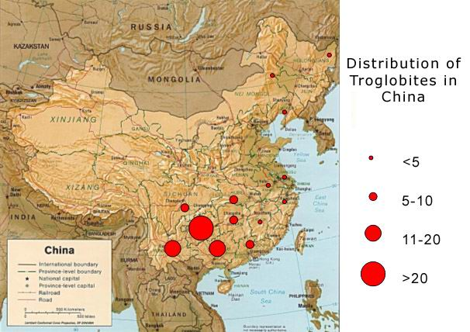

Figure 37: Distribution density of known troglobites in karst areas of China. [Sourced from Clarke & Laterlla, 2001.]

The continuing exploration of caves in continental China has lead to the discovery of many new genera and species of blind cave-dwelling beetles, particularly during the last decade and there are now over fifty described species of troglobitic or highly troglobitic trechine carabids from China (Clarke and Latella, 2001). Another example of the phrenetic activity involved with Chinese cave beetle collections can be gleaned from an examination of the beetle species listed in the copious manuscripts of Shun-Ichi Ueno, a Japanese entomologist (and son of M. Ueno) who has described new trechine carabids from caves in China and other regions of SE Asia (Ueno, 2000). The cave beetle collections by Ueno include:
- Mao County in Sichuan (September 1996);
- near Kunming in Yunnan (October 1996);
- Longshan County of NW Hunan and Xianfeng County of SW Hubei (September 1997);
- southern Sichuan (October 1997);
- Bama County of NW Guangxi and Shuicheng County & Liuzhi region of NW Guizhou (all September 1998);
- Zheng’An & Suiyang County in NE Guizhou (August 1999);
- Shiqian, Fenggang, Sinan & Jiangkou counties in NE Guizhou (September 1999);
- Xingwen County in southern Sichuan and Sandu County in SE Guizhou (November 2000);
- and Pingtang & Ziyun counties of southern Guizhou (October 2001).
In addition to the above, Japanese cavers and biologists (including Ueno) have collected beetles from:
- caves of Libo County in SE Guizhou, Feihu Dong in Longshan County of NW Hunan, and Xianfeng County of SW Hubei (all in September 1997);
- Bama & Fengshan County of NW Guangxi (September 1998);
- Southern Sichuan near Chongqing (August 1999 ); and
- Libo County in SE Guizhou (May 2001).
Further collections of trechine carabids were made by Ran Jingcheng from caves in Libo County of Guizhou in November 1997 and May & July 1999. Another French biologist (Dr. Phillippe Marti) collected three new species of trechine carabids in April 2001, from caves in Yunnan (Zheng Xiong County) during the fifth French AKL expedition. A further two species collected by Arthur Clarke during the Guangxi 2000 expedition and the more recent 2002 Hidden River Expedition have now also been described: both as new genera (Deuve, 2002).

Numerous species were collected by Italian cave biologists during their Italian expeditions to Guizhou and Yunnan in 1993, 1997 and 2000. Apart from the collections made by Lips during the French AKL expeditions, there have been other collections during the course of the
French-Chinese “Xiangxi ’93” and “Xiangxi ’95” expeditions, including the respective collections by Louis Deharveng and Anne Bedos from Longshan County (in Hunan) in July-August 1995.

A recent compilation of the troglobitic species of cave fauna in China (Figure 37) shows that three species groups with large numbers: cavefish (Balitoridae, Cyprinidae and Cobitidae), carabid beetles and copepods: Ameiridae, Calanoidae, Canthocamptidae, Cyclopidae and Diaptomidae (Chen et al., 2001; Clarke & Latella, 2001; Hubbard & Wang, 1997). Other described cave adapted species include stygobionts such as aquatic snails (Pomatiopsidae), aquatic beetles (Dytiscidae), ostracods (Cyprididae), aquatic amphipods (Bogidiellidae, Gammaridae and Pseudocrangonyctidae) and decapod shrimps (Atyidae), plus troglobitic species from several terrestrial groups: centipedes (Lithobiidae), millipedes (Cambalopsidae, Glomeridae, Megalotylidae and Sinocallipodidae), diplurans (Campodeidae), spiders (Agelenidae and Amaurobiidae), isopods (Styloniscidae), springtails (Entomobryidae and Onychiuridae) and dipteran flies (Psychodidae) (Chen et al., 2001; Huang, et. al.; Hubbard & Wang, 1997).

Cave fauna in SW China

The cave ecosystems of China are known to have a diverse aquatic hypogean (or “spelean”) fauna including a rich troglobitic ichthyofauna: cave adapted fish species (Chen, et. al., 2002; Clarke, 2001b; 2002) along with other less troglomorphic (less cave adapted) species. There are also records of several non-troglobitic cavefish, including apparent cave-limited hypogean species and the “half-cave dwelling” epigean cyprinid species that spend part of their life cycle in hypogean habitats, e.g., Sinocyclocheilus angustiporus from Mabie River, Xin-yi County, Guizhou, S. jii from streams near a cave in Fuchuan County, Guangxi; a “semi-cave” fish: Heminoemacheilus zhengbaoshani from subterranean waters near Du’An County town, northern Guangxi and Varicorhinus macrolepsis which winters in the caves of mountain catchment streams of the Changjiang River in Shansi Province (Chen & Yang, 1993b; Zhang, 1986; Zhu & Cao 1987).

Most of the known cavefish occur in these three provinces: Guangxi, Guizhou and Yunnan, where the distribution of limestone – and its solution, in an area of relatively high rainfall – have lead to the development of extensive subterranean drainage systems and associated ecosystems. The various cycles of karstification and progressive lowering of the water table are evidenced by the presence of large fossil entrances at higher elevations, where there are many large caves with gigantic chambers and passages perched high above the present water table. The intensive karstification of limestones in SW China has resulted in the formation of the present large multi-level caves that invariably contain perennial water flows (underground streams and rivers), lakes and pools or ponds, some of which are situated in now abandoned upper fossil levels where water levels are maintained by percolation seepage. Although many of these subterranean systems have external connections to epigean hydrological systems, by virtue of their inflows and outflow points (efflux resurgences or springs), there are extensive hypogean environments that remain distant and remote to external or epigean influences. Combined with their high nutrient inputs (from inflow streams draining vast catchments and the presence of guano from cave-dwelling bats and birds), many of these subterranean environments in SW China are conducive to the evolution of diverse cave faunas within extensive hypogean ecosystems.

A summary of the cave fauna highlights from the Guangxi 2000 expedition

- First known records for species from caves in this part of southern China:

- Gastropoda (land snails): Tropidauchenia cf. fuchsi, Helicorbis sp. and Hippeutis sp.;
- Depigmented ants (Formicidae) - undetermined species;
- Hemipteran planthoppers (Fulgoridae?) - undetermined species;
Springtails: Seira sensu lato; Lepidocyrtus sensu lato (both F. Entomobryidae);
- Non-glowing glow-worms! Non-luminous larvae of undetermined species of keroplatid fungus gnat; (formerly described as Family Mycetophilidae, these are now classified as F. Keroplatidae);
- Water-diving beetles (Hydradephaga) - F. Laccophilidae: Sub-family Laccophilinae: genus Laccophilus, plus other species: possibly F. Dytiscidae or Noteridae (?);
- Cave crickets (Rhaphidophoridae): Diestrammena sp. and Tachycines sp.
- Earwigs (Dermaptera) - undetermined species;
- Cockroaches (Blattoidea) - possible Calolampra sp. and undetermined species;
- Moths (Lepidoptera): undetermined species of Family Noctuidae;
- Spiders including the “Ant-mimic spider” Myrmarachne sp. (F. Salticidae) and a cosmopolitan spider, possibly Thomisus spectabilis (F. Thomisidae);
- Whip scorpions (Uropygida) - undetermined species of unknown family;
- Small shrimps (Atyidae): Neocaridina palmata palmata and Neocaridina palmata bosensis;
- Large freshwater shrimps (Palaemonidae): Macrobrachium sp.;
- Various brown and yellow decapod crabs: Chinapotamon sp.;
- Discovery of the cavefish loach: Triplophysa nanpanjiangensis (F. Balitoridae), located 1.5km underground in Dashiwei Tiankeng Dong. Only the second record of a cave loach found anywhere in Guangxi province;
- Siluriform catfish: Silurus gilberti (Siluridae) and cyprinid fish (derived from epigean waters): Parasinilabeo assimilis;
- Bats (Hipporsideridae): Hipposideros amiger – largest known species in China.

- New troglobitic species from recent “Guangxi 2000” expedition:

- Springtail (Collembola): F. Entomobryidae: 1 genus – 1 species (Coecobrya sp);
- Centipedes (Chilopoda): 2 genera – 2 unidentified species;
- Millipedes (Diplopoda): 2 genera – 3 unidentified species;
- Beetles (Carabidae): 2 new species of 2 new genera (or sub-genera) including the recently described anophthalmic (blind) trechine carabid species: Guizhaphaenops (Guiaphaenops) lingyunensis (Figure 30) from Shendong in Lingyun County (Deuve, 2002) and a new undescribed microphthalmic (tiny-eyed) species and (new) genus of carabid tribe: harpalini (or pterostichini) from Xiashuidong in Lingyun County;
- Spiders (Araneae): 2 genera – 2-3 unidentified species including pale coloured anophthalmic and microphthalmic ♀ species: F. Theridiidae (nr Icona?) and juvenile F. Pholcidae;
- Undetermined microphthalmic opilionid (harvestman);
- Blind (anophthalmic) decapod shrimp. (Originally thought to represent a new Family, now considered as F. Palaemonidae): 1 species, possible new genus (similar to Macrobrachium sp.). This is the first record of a blind palaemonid in China and possibly only the second record for SE Asia;
- Pink and translucent cavefish: 2 genera – 2 new species: one is possibly Pterocryptis sp and the other a cave ecotype of Silurus gilberti. Both species (F. Siluridae) have reduced eyes and different numbers of barbels of varying lengths. (These “barbels” are antenna-like structures that act as sensory “feelers”.)

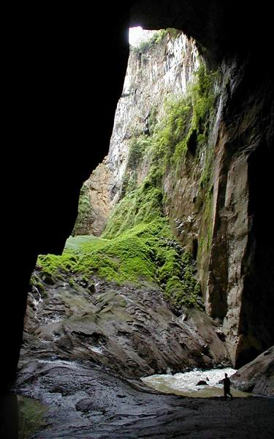

Figure 38: Caver at the base of Yanliu Dong (south of Lingyun), 220m below the
abseil entry point

Footnote

Despite the fact that many cave systems in China include vast underground river systems, there appears to be a general dearth of aquatic troglobites because many of these subterranean hydrologies are effectively just floodwater conduits directly linked to surface streams. Many of these cave systems have fast flowing streams carrying vast amounts of surface matter as natural and unnatural flood debris containing organic matter (tree logs and branches) plus an amazing array of rubbish (including plastic bags, bottles, cans and clothing items all derived from the “throw-away” Chinese society). Some cave streams also contain agricultural products (fertilisers and herbicides) which act as pollutants to aquatic organisms. The few cave adapted aquatic species (copepods, decapod shrimps and cavefish) tend to be found in percolation fed pools or streams in the upper (fossil) levels of caves or where there are slow-moving cave streams that are isolated from surface influences, e.g., in some of the deep or long caves in southern China or in the very few areas remote from human settlement. Many of the caves of China have been impacted by villagers:
- prospecting or mining bat or bird guano deposits for nitrate or phosphate;
- exploited as food sources (extracting bats and blind cavefish for food); or
- modified for accessing cave water to irrigate crops or for hydro-electric power.

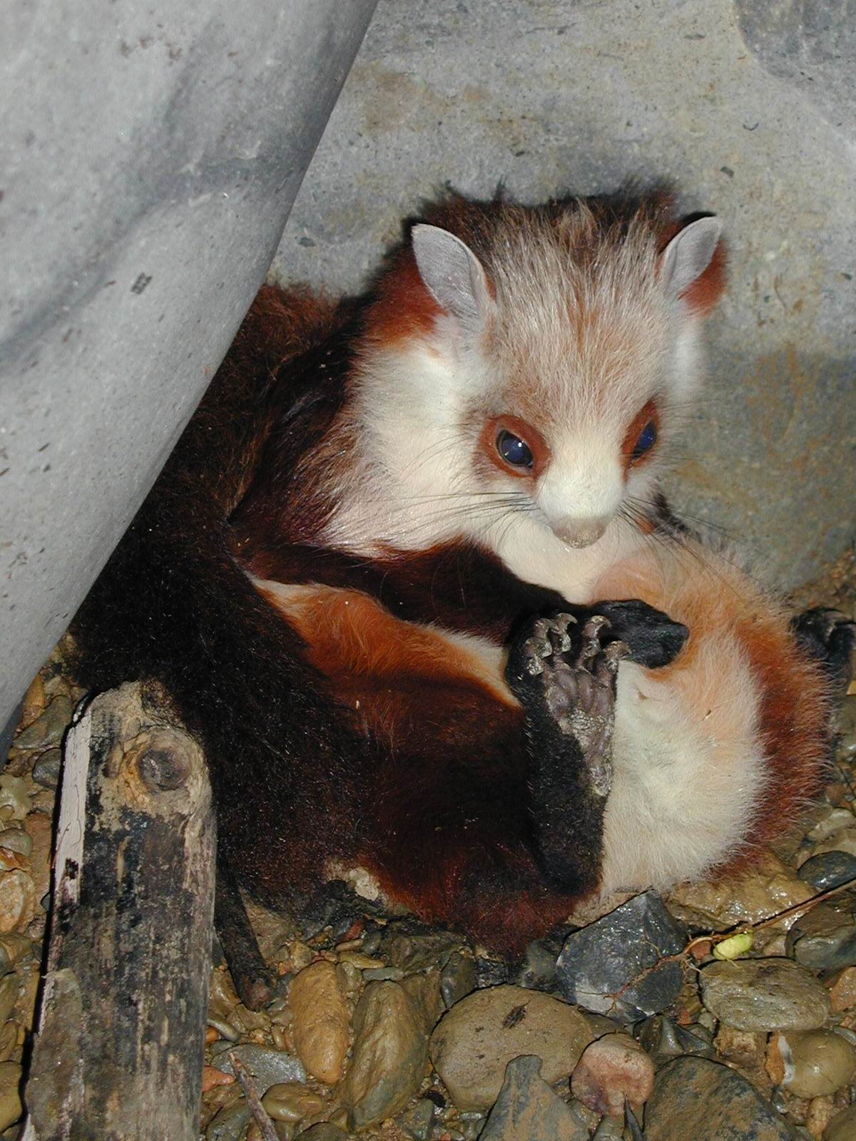

Figure 39: One of two feimaos “flying cats”): Red-and-White Giant Flying Squirrels (Petauridae: Petaurista alborufus), found at the base of the 350m deep Fong Yen in Leye County; these frightened animals were rescued by cavers. (Photograph by Chen Lixin.)

References

BRIDGEMON, R. R. and LINDSLEY, K. B. 1991. South China Caves: information on the Caves and Karst of South China and a Report on the 1988 Joint Expedition between the Institute of Karst Geology, the Speleological Society of South China Normal University and the Cave Research Foundation. Cave Research Foundation, Tucson, Arizona, USA. 61pp.
CAGS (CHINESE ACADEMY of GEOLOGICAL SCIENCES). 1976. Karst In China. Institute of Hydrogeology and Engineering Geology, Chinese Academy of Geological Sciences, Shanghai People’s Publishing House, Shanghai, China, February 1976. 144pp.
CAMPION, G. [Ed.] 2001. The YRC Guangxi Caves 2000 Expedition. The YRC Bulletin, 15 (Summer 2001): 1-66.
CHEN X., et. al. 1998. South China karst (1: Karst studies of Yunnan; 2: Cave studies of W. Guizhou). Znanstvenoraziskovalni center Slovenske akademiji znanosti in umetnosti Založba ZRC. ISBN 961-6182-86-4 (zv. 1)
CHEN Y. and YANG J, 1993. Species and origin of cave-dwelling Sinocyclocheilus fishes. Proceedings of XIth International Congress of Speleology, Beijing: 123-124.
CHEN Y, CHEN Z and YANG J., 2002. Cave fishes of China. Memoires de Biospéologie (International Journal of Subterranean Biology), Tome XXVIII, 2001: 181-184. (Published November 2002.)
CHEN, Z., DECU, V, JUBERTHIE, C. and UENO, S-I. 2001. China. Encyclopaedia Biospeleogica, Part III, Société Internationale de Biospéologie, Laboratoire Souterrain, Moulis, France, pp. 1763-1781.
CLARKE, A. 2001a. Shendong, pp. 20-24, in CAMPION, G., [Ed.] The YRC Guangxi Caves 2000 Expedition. The YRC Bulletin, 15 (Summer 2001): 1-66.
CLARKE, A. 2001b. Cavernicole diversity in western Guangxi Province, SW China. Speleology in the Third Millenium: Sustainable Development of Karst Environments. Proceedings of XIII International Congress of Speleology, Brasilia, July 15-22, 2001: p. 152.
CLARKE, A. 2002. Cone karst, caves, cave fauna & karst management in southern China. Cave Management in Australasia 14: Proceedings of 14th Australasian Conference on Cave & Karst Management, Wombeyan Caves, New South Wales, 29 April to 6 May 2001: 38-56.
CLARKE, A., CHEN, X. and CHEN, Z. 2002. Amended checklist of cave fishes in China. Paper presented to the 16th International Society of Biospeleology symposium, Verona, September 8-15, 2002. In press to International Journal of Subterranean Biology. 19pp.
CLARKE, A and LATELLA, L. 2001. in press. Preliminary assessment of the cavernicolous fauna of central-south China. 15th International Symposium of Biospeleology. Intervales, Sao Paulo, Brazil, July 8-15, 2001. [Abstracts of the XVth International Symposium of biospeleology. Sao Paulo: Société internationale de Biospéologie, p. 26]
CROSSLEY, P., EMBERSON, R. and YANG, M. 1988. China – New Zealand Speleological Exchange Expedition Report: Speleological Investigations in Guizhou (3-28 September, 1987) 78pp.
DEUVE, T. 1993. Description de Dongodytes fowleri n. gen., n. sp., Coléoptère troglobie des karsts du Guangxi, Chine (Adephaga, Trechidae). Bulletin de la Société entomologique de France, 98 : 291-296.
DEUVE, T. 2002. Two remarkable new anophthalmic trechines from caves of northwestern Guangxi, China (Coleoptera, Trechidae). Bulletin de la Societe entomologique de France (Bulletin of the Entomological Society of France), December 2002.
FOGG, P. and FOGG, T. 1988. China Caves Project 1987-1988: The Anglo-Chinese Project in Caves of South China. China Caves Project, 32pp.
FOWLER, S. 1988. Cave Biology. in Fogg, Pam & Fogg, Tim (Eds.): China Caves Project 1987-1988: The Anglo-Chinese Project in Caves of South China. (Page 32)
FOWLER, S. 1990. Biology of the Caves of Guangxi. Cave Science, 17 (3): 77-80.
GEELAN, P.J.M. and TWICHETT, D.C. (Eds.) 1974. The Times Atlas of China. Times Books, London. xl + 144 + 25pp.
HUANG, H., LI D-H., PENG X-J. and LI S-Q. 2002. Two new troglobitic species of the genus Coelotes from China (Araneae: Amaurobiidae). Acta Zootaxonomica Sinica, 27 (1): 78-81.
HUBBARD, D. and WANG, D. 1997. A preliminary report on some invertebrate cave fauna of China. Proceedings of XII International Congress of Speleology, La Chaux de Fonds: 311-313.
RU J., ZHU, D. and LIU, G. 1991. Karst in Guilin: geoscientific guidebook. (Regional Karst Research Section, Institute of Karst Geology.) Press of University of Science & Technology of China, Jinzhai Road, Hefei, PR China. 77pp.
UENO, S-I. 2000. New Cave Trechines (Coleoptera, Trechinae) from Northeastern Guizhou, South China. Journal of Speleological Society of Japan, 25: 1-28 (December 30, 2000)
WALTHAM, T. 1986. China Caves ’85: The first Anglo-Chinese Project in the Caves of South China. Royal Geog. Society, London. 60pp.
WALTHAM, T. and WILLIS, R. 1993. Xingwen: China Caves Project 1989-1992. British Cave Research Association, Bridgewater. 48pp. ISBN 0 900265 15 9
WENG-CHUNG, P. 1940. The upper cave fauna of Choukoutein, Chungking. China Geological Survey, 1940 in Palaeontologica Sinica, 10.
WORTHY, T. 1994. The New Zealand – China Exchange Expeditions. N.Z. Speleological Bulletin 9 (169) March 1994: 241-261.
ZHANG Y. 1993. The Contributions of Xu Xiake to Speleology. Proceedings of XI International Congress of Speleology, Beijing: 246-247.
ZHU S. and CAO W. 1987. The noemacheiline fishes from Guandong and Guangxi with descriptions of a new genus and three new species. Acta Zootaxonomica Sinica, 12 (3): 327.
ZU Q. 1993. Discovery of Nanjing Man and its significance. Proceedings of XI International Congress of Speleology, Beijing: 131-134.

